**SPRINT 3**

|  |  |
| --- | --- |
| **DATE** | **18 NOV 2022** |
| **TEAM ID** | **PNT2022TMID41072** |
| **PROJECT NAME** | **EARLY PREDICTION OF CHRONIC KIDNEY DISEASE USING MACHINE LEARNING** |

**In this sprint we are doing normal deployment**

 **App.py Code Screen**

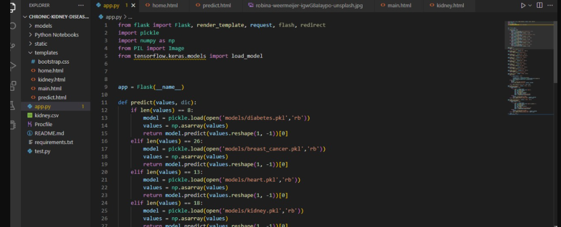

**home.html Code Screen**

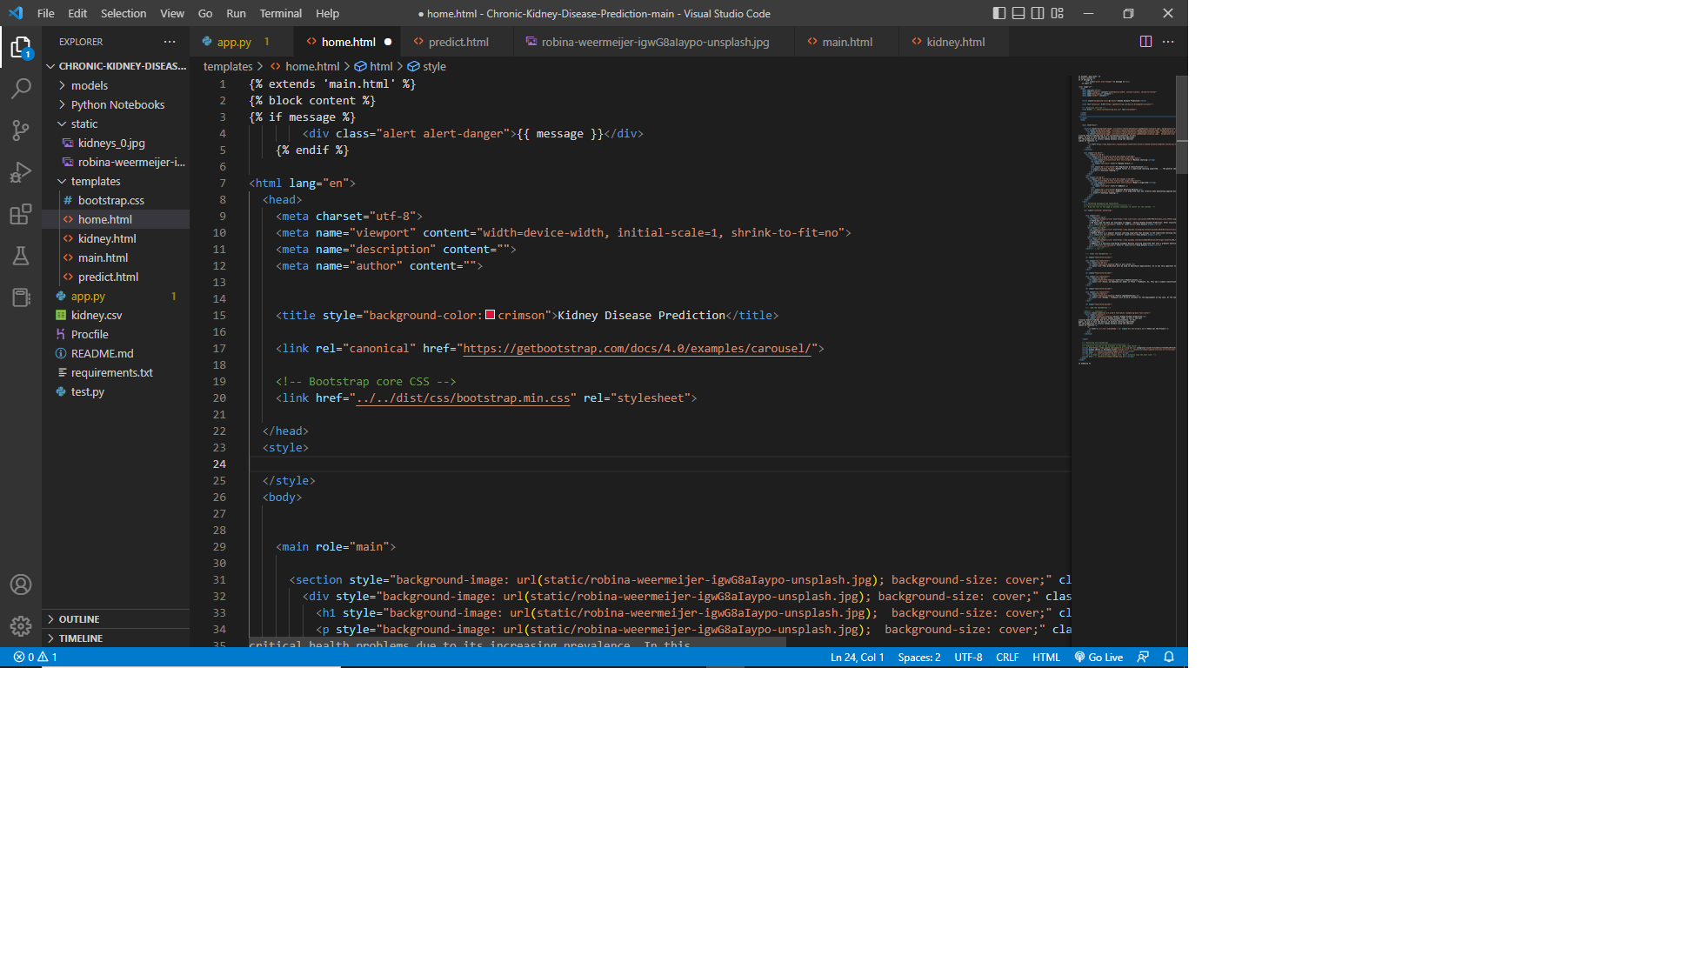

**Kidney.html code screen**

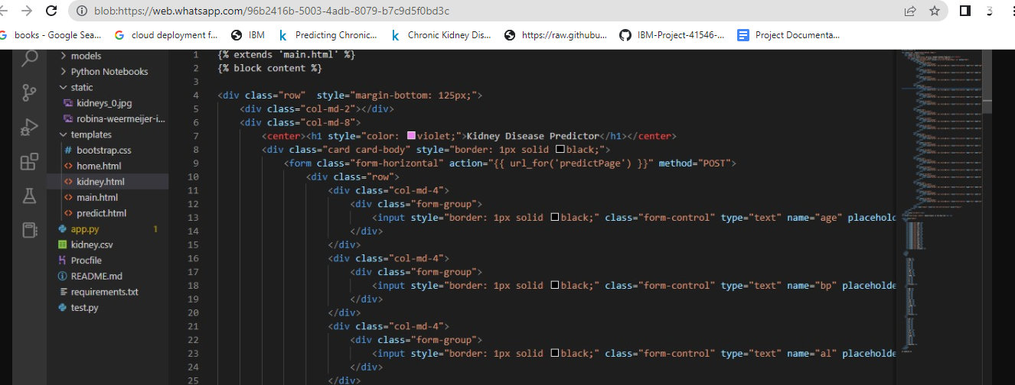

**Main.html code screen**

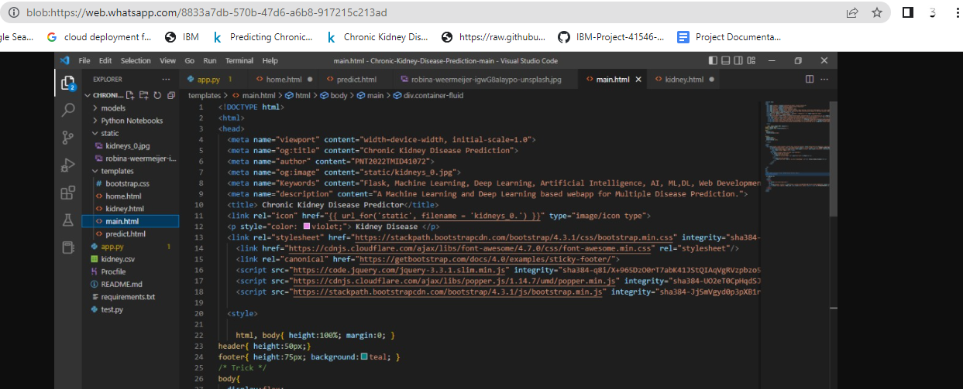

**Predict.html code screen**

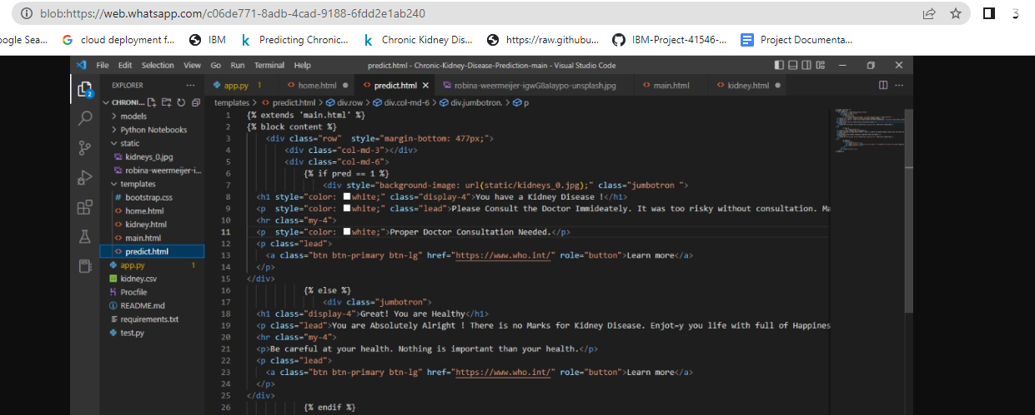

**Home.html output screen**

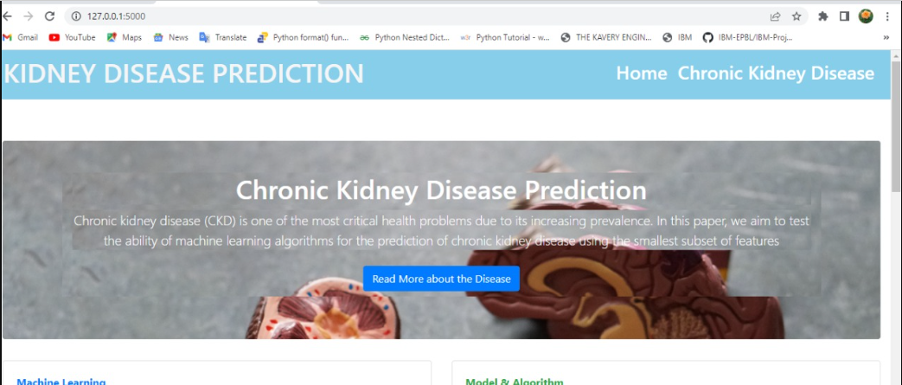

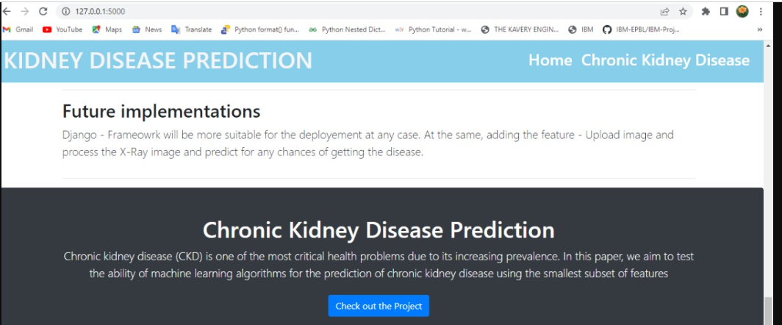

**Kidney.html output screen**

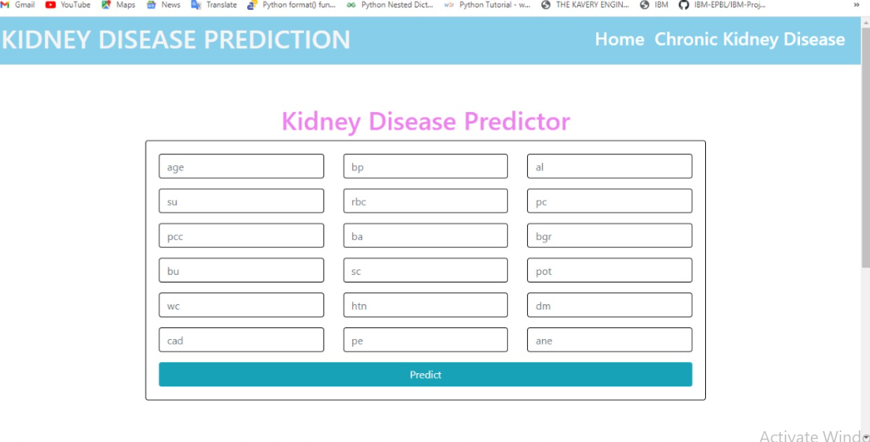

**Predict.html output screen**

